Have a go at Charlie’s eggsperiment-can we make an egg bounce?

WHAT YOU WILL NEED
- 1 raw egg
- White vinegar
- A bowl
- Golden syrup
- Food dye
- Kitchen roll
- Scales
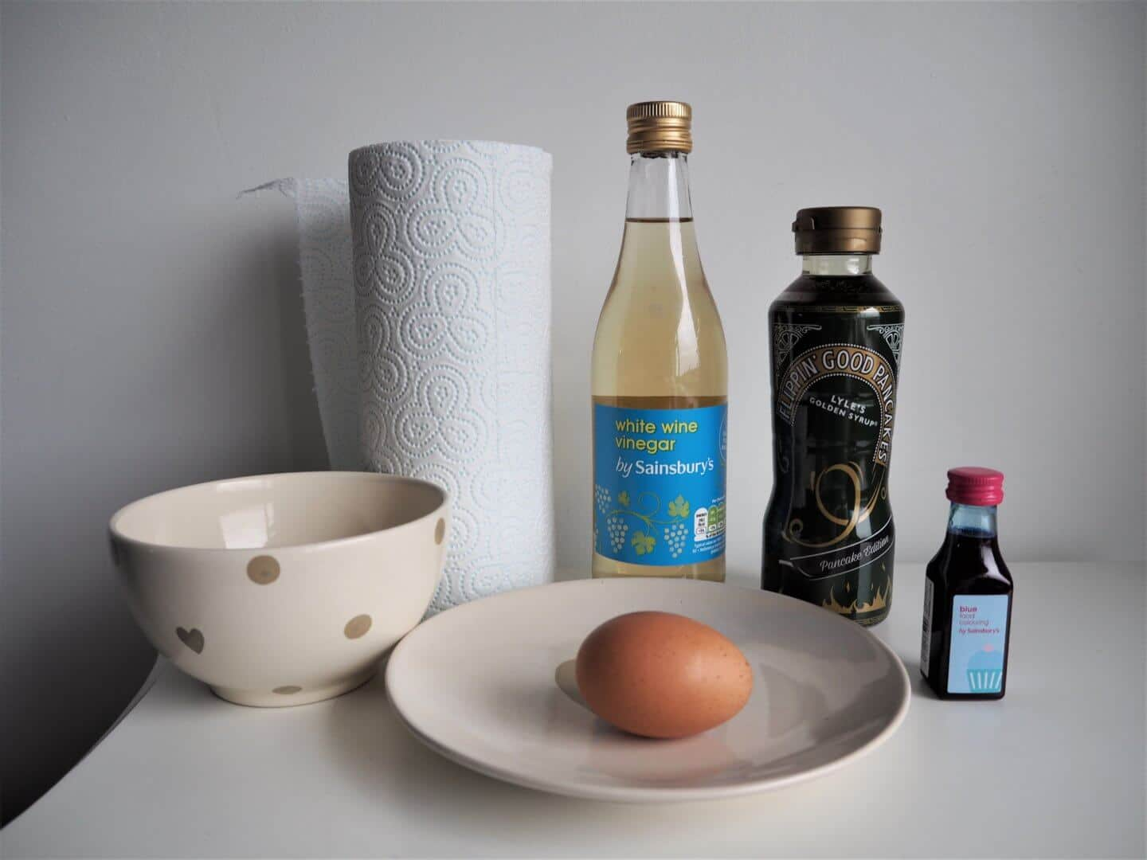

WHAT YOU NEED TO DO
- Place the egg in a bowl and pour the vinegar in until the egg is fully covered. We put a plate on top of the bowl to ensure it stayed submerged in the vinegar.
- 72 hours later, carefully empty the vinegar and gently rinse the egg with tap water so that all the shell is removed.
- If there are patches of shell, do not scratch them off as it may puncture the egg. Try gently rubbing and rinsing it off. If it won’t come off, place back in the bowl with fresh vinegar and leave for another 24 hours.
- Dry your egg carefully on a piece of kitchen roll – then you’re ready to start experimenting!
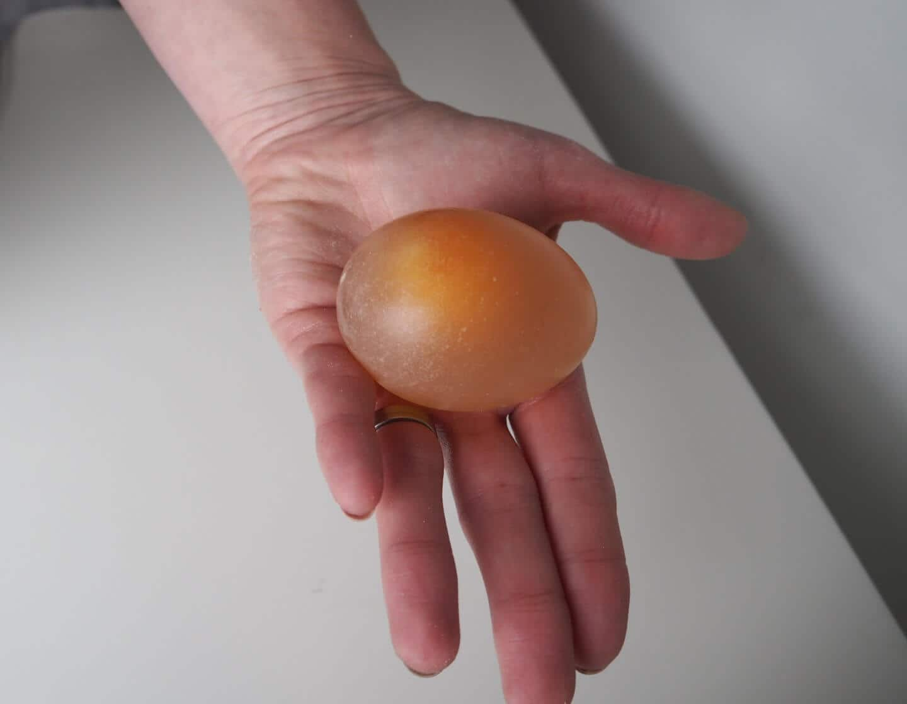
- Drop the egg from a height of around 20cm onto a flat surface and hopefully it will bounce. After dropping it, weigh the egg and write down its weight.
- Place the egg in a bowl and completely cover it with golden syrup. Leave this for six hours. When you take it out, the skin is wrinkly and the egg soft. Dry and weigh the egg – hopefully it will be lighter than before!
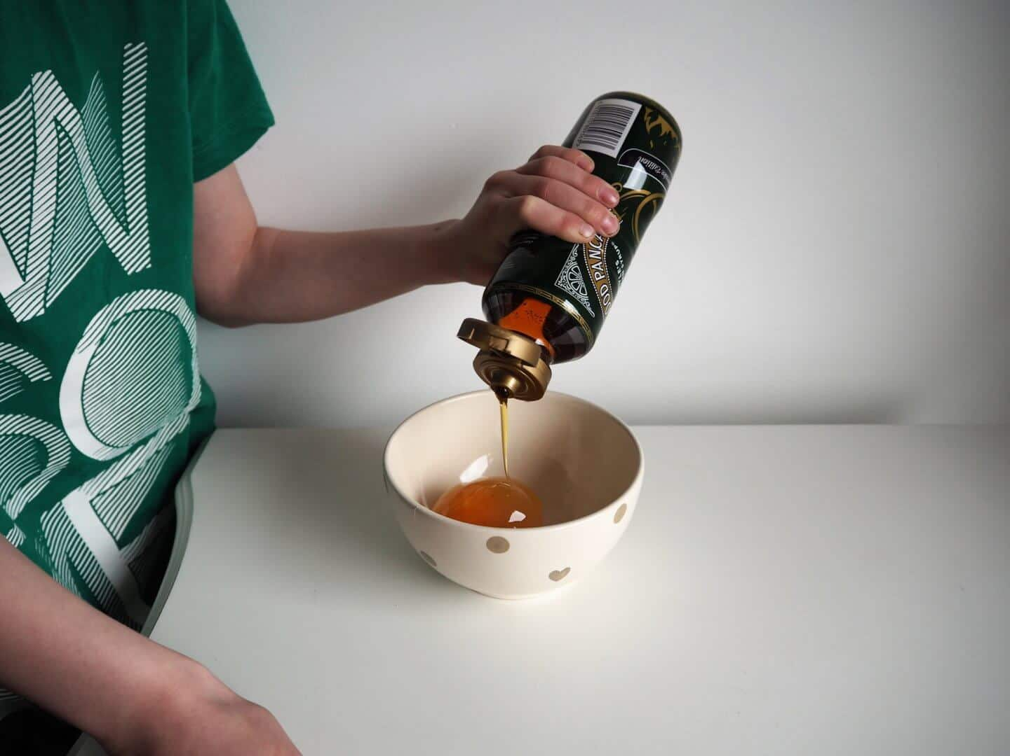
- Place the lighter, wrinkled egg into a bowl of water with a few drops of food dye. After around 6 hours, take the egg out and you should notice the egg is firm again and bouncy. After drying it, weigh it again – it should be heavier again! If you look closely, you should be able to see that the egg is now the colour of the food dye. The egg should bounce better than it originally did, but don’t drop it from too great height as it will burst everywhere!
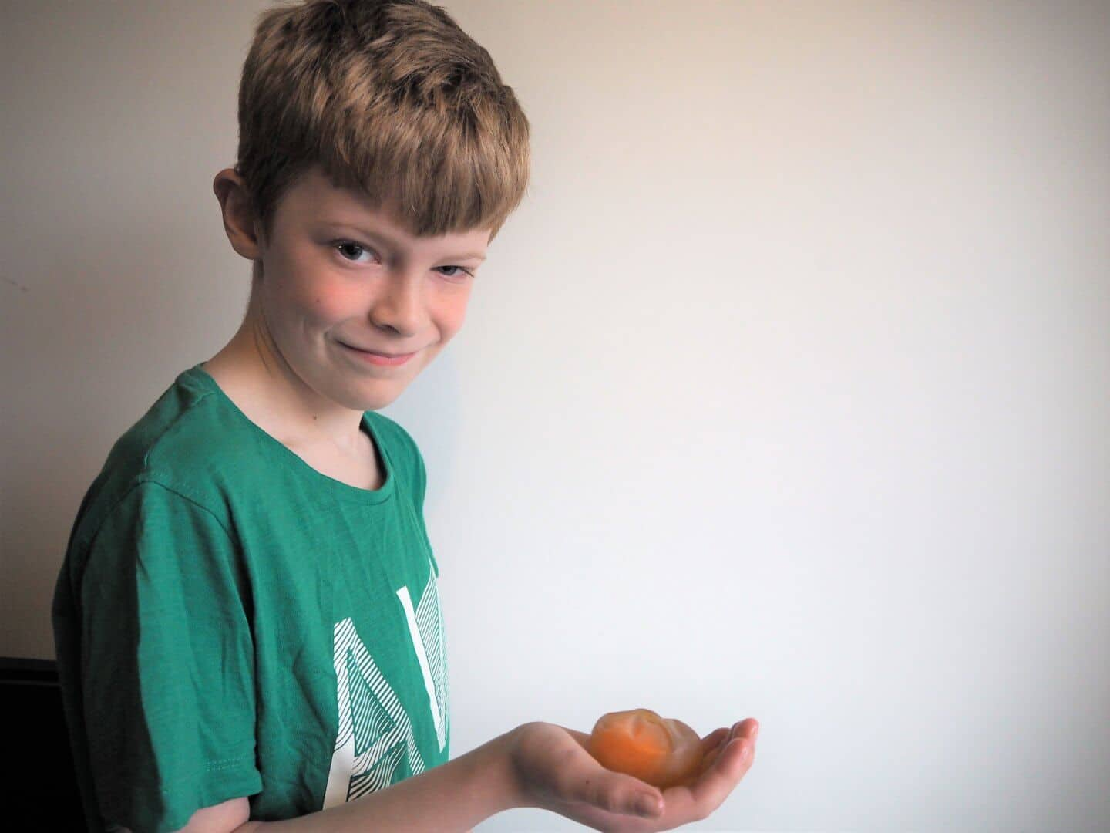
After the syrup – it is almost see through!

Sadly our first egg broke (luckily I tested it over the bath as it went splat!) Being totally honest, I think I hadn’t completely got all the shell off properly and then our second one leaked a little due to some too vigorous rubbing from me! Luckily, I soaked three eggs at once so number three was our lucky egg.

Want to see how we got on? Here’s our vlog documenting our bouncy egg trial

The question Charlie kept asking me – why does it bounce? So here’s the Science-y bit!
The vinegar is a weak acid. It reacts with the shell, removing it without affecting the egg inside. This is because the egg is surrounded by a strong skin called a membrane which acid does not affect. The membrane allows water to pass through but stops other things. This effect is called ‘osmosis’. This experiment is an example of osmosis through a semi-permeable membrane (take that!)
So, when you put the egg into the syrup, water passes out of the egg through the membrane and the egg becomes lighter. Alternatively, when you put it into water (with food colouring) the water passes into the egg and it gets heavier.
When you have finished the experiment, why not place the egg into a basin and cut open the membrane! You should find a raw egg with food dye – pretty cool huh?
Did you notice that when the acid of the vinegar reacted with the egg-shell it was an irreversible reaction as you can’t grow the shell back! The shell of the eggs is for protection and the membrane surrounding it protects the growing chick from, among other things, drying out.
You can find out more about Terrific Scientific and get involved with your kids this Easter. You can get more information over here at the Terrific Scientific hub .
If you are wanting to recreate our experiment please read this safety note aimed at supervising adults first:
This Terrific Scientific investigation has been devised so that with adult supervision, reasonable care and by following the instructions provided, no special safety equipment or knowledge is required to enjoy the experience safely. These safety reminders are designed to assist the supervising adult when planning and carrying out the investigation. Please read the instructions fully before starting.
- Wash the eggs at the start of the investigation.
- Wash your hands at the end.
- Do not eat the egg at the end.
